

APIC Drupal Theme Deployment Process

Date: May 21, 2019

Version: 1.00

Next Refresh Date: May 2019

Overall Maturity: Emerging

Table of Contents

2 3

1. Executive Summary 3

2. Introduction 3

2.1 Purpose of This Document 3

2.2 Who is the Intended Audience? 3

2.3 Scope 3

2.4 Document Metadata 3

2.5 Document History 3

2.6 Review Team 4

3 Overview 4

3.1 APIC Platform Installation & Configuration – Installation & configuration of APIC 4

3.2 Integrating Custom Theme into APIC Portal- 4

3.3 Core files of Drupal 7(Files not to be modified) 5

4 Git Location / Structure 5

5 6

6 Modified Files 6

7 Configure Jenkins Job & Tie it to Git and Artifactory 7

7.1 Connecting github repository with Jenkins 7

7.2 Creating first job on Jenkins 9

8 Enabling Theme 15

# 

# Executive Summary

IBM API Connect is a complete, modern and scalable API platform that lets you create, securely expose, manage and monetize APIs across clouds so that you and your customers can power digital applications and spur innovation.

API Connect lets you centrally manage your APIs across multi cloud deployments. It offers security-rich support to deploy and independently scale components based on workload across multiple diverse services and platforms, including public clouds like IBM Cloud, Amazon Web Services and Microsoft Azure, and private clouds like IBM Cloud. This innovative container- and micro services-based design provides you with unmatched scalability and performance.

# Introduction

## Purpose of This Document

The purpose of this document is to detail out the process required to deploy the Drupal themes related to Internal and/or External APIC Portal.

**Note** - The process of deploying the themes related to APIC internal or external portal is same.

## Who is the Intended Audience?

This document is primarily intended for team who is responsible of setting up API Platform for the Internal/External Portals. This document is not intended for developer team.

## Scope

The scope of this document is to describe the process & the steps required for the deployment of Drupal related themes for the APIC Portal. This document shall not cover the CI/CD process related to the infrastructure setup of the APIC Portal. However, it will be a process component, which needs to be integrated with the larger APIC Infrastructure setup.

## Document Metadata

## Document History

|  |  |  |  |
| --- | --- | --- | --- |
| **Version** | **Date** | **By** | **Description** |
| 1 | 15/5/2019 | Dhanasekaran | Version 1.0 completed. |

## Review Team

|  |  |  |
| --- | --- | --- |
| **Team** | **Reviewer** | **Involvement** |
| Onsite | Ananta Guha |  |
| Onsite | Darwin |  |

# Theme Deployment

This document gives a high-level overview of the process involved in setting up a custom Drupal theme for any APIC Platform. Below is a typical 4-step process for setting up APIC Portal. A step to configure bespoke APIC Drupal Theme is one of the steps in realizing the APIC enterprise platform. Each of the steps are, described below.

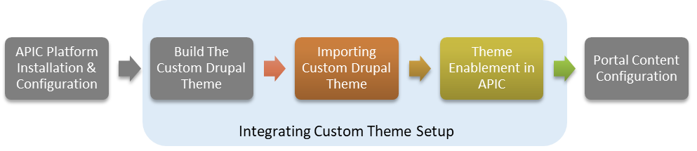

## APIC Platform Installation & Configuration – Installation & configuration of APIC

Platform is part of the one of the pre-requisite step for integrating a custom theme into APIC portal. Post installing APIC product, the base themes are extracted to its base installed folder & file system. Once the configuration of APIC product is completed then the next step towards setting up of themes can be taken up.

***Note:*** *Installation & Configuration of APIC Platform is out of scope of this document*

## Integrating Custom Theme into APIC Portal-

Integrating APIC Theme can be done in 4 simple steps, described below.

1. **Build the Custom Drupal Theme** - as per the look & feel requirement of the Internal/external portal. Some of the fundamental files which are modified for Hartford are
   1. **CSS**
   2. **Images**
   3. **JS**
   4. **SCSS**

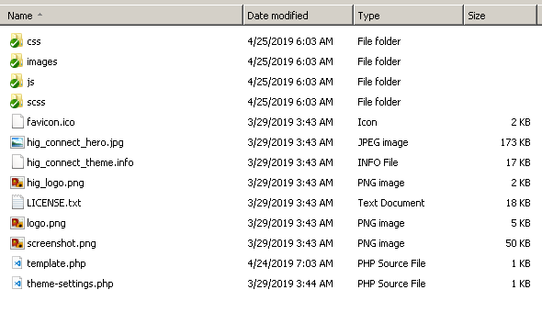

Figure 1: Sample Drupal Sub-Theme files

***Note****: Details of building of the custom theme is out of scope of this document.*

1. **Import the Custom Drupal Theme Files/Folders -** The custom themes, a.k.a. sub-themes of drupal needs to be pulled from desired content management site/system (e.g. GitHub, SVN etc.) & moved/imported to a specific folder as described below in the diagram. The relative path of the custom theme for Drupal 7.x is */Sites/all/themes/<<custom themes go here>>.*

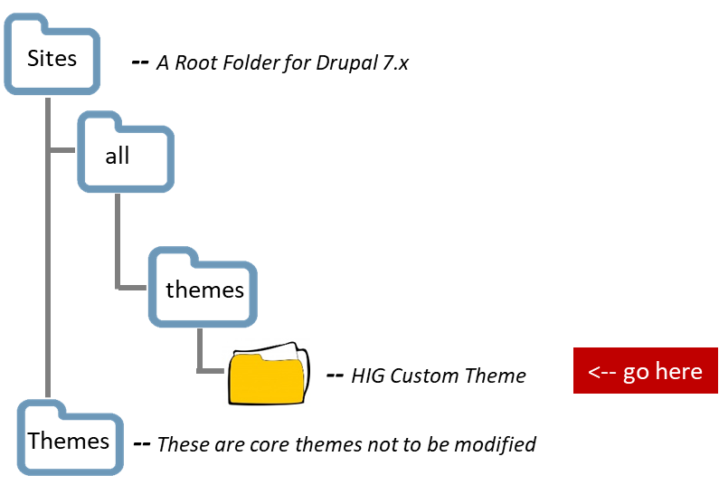

Figure 2: Drupal 7.x Folder Hierarchy

***Note:*** *There needs to be necessary access & privileges for the user having access to the source (i.e. SCM Tool/ GitHub pickup location) & destination folders (Root folder of Drupal 7.x), before the user moves the file under the themes folder*

1. **Files not to be altered –** Below is the list of files, which should have restricted access & should not be altered.

* **/includes:** Helper functions (e.g. image manipulation, password generation etc.)
* ***/misc:*** JavaScripts, icon-images for messages etc.
* ***/modules:*** the modules from the Drupal core.
* ***/profiles:*** the installation profiles from the Drupal core (minimal, standard, testing). Drupal will ask you which profile you want to install when first installing your Drupal site.
* ***/scripts:*** contains various scripts. e.g. to execute the cron, dump the database, generate a password hash and run the tests.
* ***/themes:*** here are the Drupal core themes located. Such as the default Bartik theme and the Seven theme which is the default one for administration pages.
* ***/sites:*** Here comes anything which is not part of the Drupal core. Contains an "all"- and a "default"-folder. In the "all"-folder we can place custom and contrib modules and themes. Additionally here's a "default"-folder where our site configuration resides. After a Drupal site is installed, there will be a settings.php file in the "default"-folder, where usually the database configuration and other site-specific configurations are.
* ***/sites/all/modules:*** Here we can put all our contrib and custom modules.

1. **Enable the Custom Drupal Theme-**  Below are steps

* ***Login as admin*** – Login with necessary admin privileges into APIC Portal (Internal/External) ?
* Choose the hig_connect theme and click “Enable and set default”
* Visit the home page. You can see the updates of latest code.
* You have done the theme update

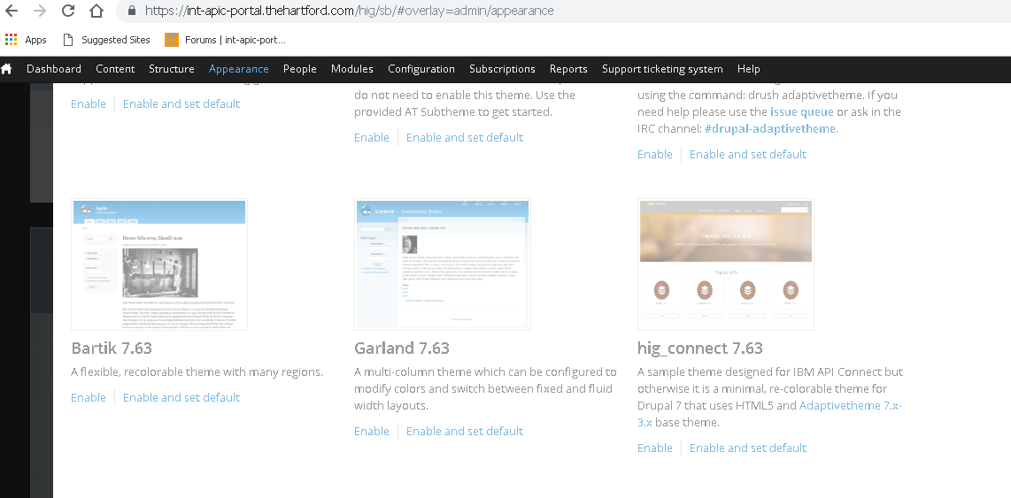

Figure 3: Drupal 7.x Sample Selection Page

## Portal Content Configuration - This topic is covered as part of “APIC Content Management” document & is out of scope of this document.

# Content & Configuration Migration for Drupal

Below describes a typical manual process steps for deploying the Drupal configuration.



Figure 3: Drupal 7.x

1. Install Feature Module – The first step to build the Drupal configuration is to select the   
   “Feature” module for Drupal configuration. With feature we can export Drupal content & configuration & deploy into another environment
2. Feature Type Creation- Select the desired configuration from components. One can select one or more than one component.
3. Export the Configuration – Export the selected configuration as a zip format. And place into the desired targeted environment (DEV/QA/PROD). Note, this can also be achieved using drush script commands ( e.g. **features-export)**
4. Deploy the Configuration - Place the exported zip folder into Drupal 7.x is */Sites/all/module folder.* Note, this can also be achieved using drush script commands (e.g. **features-update),** this will also install the configuration**.**
5. Feature Installation – Goto module’s page & select the feature & click on Save. This will import the entire configuration for the targeted environment. Note, this can also be achieved using drush script commands (e.g. **features-update).**

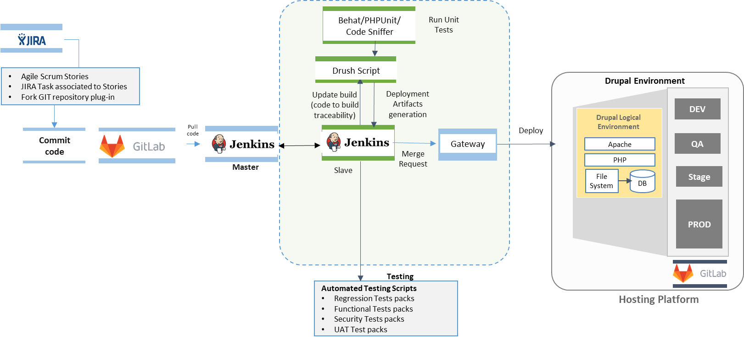

Figure 4: CI-CD Drupal Deployment Flow